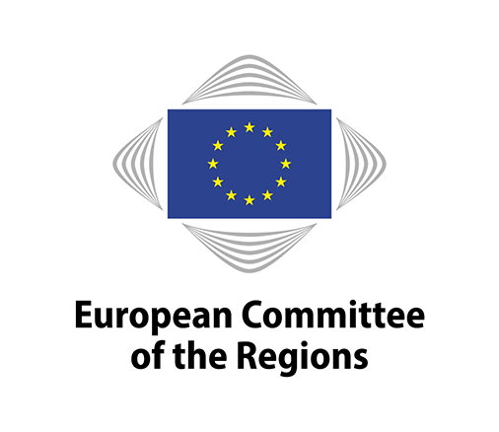 | Press release
CoR/18/050.en
Brussels, 20 March 2018.

Brexit report: social and economic impact on cities, regions and businesses
The European Committee of the Regions (CoR) published a report today in Brussels detailing the consequences of Brexit on trade and the economy in the EU27 regions and cities. Based heavily on data gathered from a joint survey with EUROCHAMBRES, the report reveals a lack of awareness, information and preparation and recommends greater flexibility in state aid rules and inter-regional cooperation.

A year ahead of the scheduled departure of the UK from the EU, uncertainty surrounding the nature of the future EU27-UK relationship complicates the process of adjustment for many EU regions. This uncertainty which was also not eased out by the latest transition deal is compounded in many cases by a lack of analysis of the likely impact on local economies. In turn, this restricts local and regional authorities’ capacity to formulate strategies to address the adverse effects of the UK leaving the EU on their economies.

"The results of both this report and the CoR's territorial impact assessment show that there will be no winner from Brexit and that Europe's local and regional authorities already know it. After the UK, Irish regions will be the most economically and socially impacted by Brexit because of their close relations and direct border with the UK. However, regions in Germany, the Netherlands, Belgium, France, Italy and Spain also anticipate a severe impact. Whilst still difficult to assess the precise consequences for each European region or city, it is already possible and necessary to take action at European level to counter negative impacts and soften the blow", said Michael Murphy, Head of the Irish delegation in the CoR and member of Ireland's Tipperary County Council.

The CoR and EUROCHAMBRES conducted a survey of regional and city authorities and chambers of commerce to feed into a process of analysing and debating the exposure of EU27 regions and cities to Brexit. This resulted in the report presented at a joint briefing in Brussels today (read the full report here), summarising the expected economic and social effects and the impact on public administrations, and setting out conclusions and recommendations.

"The survey results show that chambers sense a greater exposure to the effects of Brexit. This is not surprising given that EU27 businesses will directly feel the additional friction in trade that will result from the UK leaving the EU customs union and single market", said Arnaldo Abruzzini, CEO of EUROCHAMBRES. "We must now seek to minimize that friction, which requires precise quantitative and qualitative feedback, so it’s worrying that this process also reveals a lack of analysis in many regions of the specific effects of Brexit. This needs to be addressed swiftly if the EU27’s regions, cities and businesses are going to be well-placed to adjust effectively."

The report concludes that there is a need for more specific, localised impact studies to get a better understanding of the potential impact and of the linkages across and between business sectors. Awareness raising and information sharing will further help businesses, notably SMEs, to be better prepared to face the ensuing structural and economic adjustments.

The report also echoes proposals from the CoR's opinion on “The European Commission Report on Competition Policy 2016”, drafted by Mr Murphy, to allow greater flexibility of State aid rules. It further highlights the importance of continued interregional cooperation between EU27 and UK regions post-Brexit and the need for territorial cooperation programmes and macro-regional strategies to share information and pool resources.

Background:

The CoR started a process of analysing and debating the exposure of EU27 regions and cities to Brexit, to prepare for the repercussions of the UK's withdrawal and the potential asymmetric territorial impact within the EU27 (with some regions substantially affected). The process resulted in a shared report and included a discussion between CoR members and the chief EU negotiator Michel Barnier, the adoption of a resolution, a study, a Territorial Impact Assessment workshop and a survey in cooperation with EUROCHAMBRES.

The dedicated CoR interregional group on Brexit, made up of 29 members from seven Member States, will meet for the first time in Brussels on 23 March 2018. Meanwhile, EUROCHAMBRES Brexit Working Group will convene on 20 March and EUROCHAMBRES President, Christoph Leitl, will speak at a European Parliament Trade (INTA) Committee on Brexit and future trading relations on 21 March.

Contact:

European Committee of the Regions EUROCHAMBRES
Carmen Schmidle Luis Piselli
Tel. +32 (0)2 282 2366 Tel. +32 (0)2 282 0892
carmen.schmidle@cor.europa.eu press@eurochambres.eu

