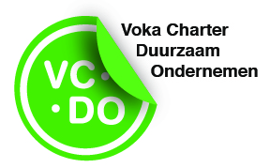
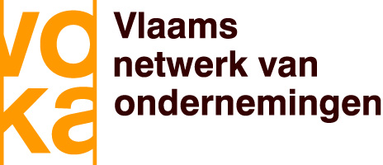

The Voka Charter Sustainable Entrepreneurship (VCDO) is an annual reward that certifies that the company took significant steps towards the realization of corporate sustainability.
The United Nations Sustainable Development Goals (SDGs) constitute the universal framework in this regard. Voka is convinced that businesses can make an important contribution to achieving the SDGs and developed the VCDO based on these universal goals.

Basic principles

Each company that subscribes to the Voka Charter Sustainable Entrepreneurship, undertakes to:
- Integrate corporate sustainability in its company policy in a proactive manner
- Formulate goals and specific actions that are consistent with the United Nations SDGs
- Report on the results achieved to the evaluation committee
- Communicate externally on the actions implemented
- Continuously work on compliance with social, welfare and environmental legislation

Who can participate?

Any business or organisation can apply to participate, regardless of the size of the company, the number of employees or the nature of its activities. The only precondition is the commitment to comply with social, welfare and environmental legislation, and to draft and implement an action plan.

How is participation organised?

Evaluation committee

An evaluation committee, led by an independent chairperson and comprised of independent experts and representatives from diverse government departments, organisations and the corporate sector, examines the extent to which the action plan has been achieved. This takes place as part of a constructive collaboration with the participating companies.

UNITAR certificate
Enterprises that have participated in the VCDO three times within a time frame of maximum five years and have implemented an action in each of the 17 Sustainable Development Goals of the United Nations during this period, receive a UNITAR certificate from CIFAL Flanders - UNITAR (United Nations Institute for Training and Research) – www.unitar.org

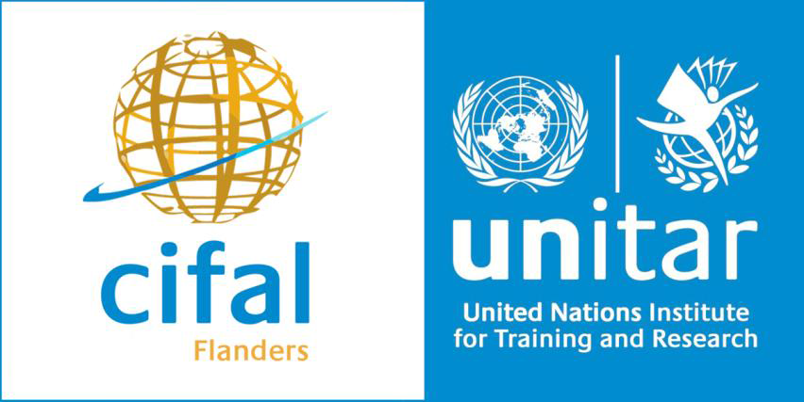
The objective of CIFAL Flanders is to promote the declarations and principles of the United Nations, and in particular the Sustainable Development Goals. Being one of the 15 UNITAR training centres, it is part of an international network. It strives to help (local) authorities, institutions, organisations and the corporate sector to embed the Sustainable Development Goals in their company or organisation's strategy – www.cifal-flanders.org

